JMETER: CHALLENGES & RESOLUTON

Project Name | Risk Master Application Performance Analysis

Prepared By | Date of Preparation
Kumud Naithani | November 14, 2016
Reviewed By | Date of Review
Mahendra Pratap Singh | November 18, 2016
Version Number | Version Change Date
0.00 D | November 14, 2016
Modified By | Modification Info

Contents
JMETER: CHALLENGES & RESOLUTON 1
1 Introduction: 3
1.1 Purpose: 3
2 FAQ: 3
2.1 What Is Jmeter: 3
2.2 What Are Jmeter’s Advantages As Performance Test Tool: 3
2.3 What Is Basic Jmeter Tool Work Flow: 4
2.4 How To Establish Real Time Web Communication Environment In Jmeter Tool: 4
2.5 Is Jmeter Capable To Handle Multiple Data Sets: 5
2.6 How Is Dynamic Response Data Generated During Test Run Captured In Jmeter: 5
2.7 How Is Correctness Of Web Requests Captured In Jmeter Established: 5
2.8 How Is Correctness Of Performance Results Provided By Jmeter Established: 5
2.9 How Is User Friendly Performance Test Report Generated For Jmeter: 5
2.10 How Is Memory Low Issue Taken Care While Running Test For Large User Count: 6
2.11 Is It Possible To Run Jmeter Test Cases As batch Or Suite: 6
3 Revision History Of The Work Product: 6

Introduction:

Purpose:

- Following document provides an insight to:
- Basic J-Meter Understanding
- Challenges faced during J-Meter Tool Implementation in Risk Master Application (RMA) Project
- Measures to ensure correct performance output while Performance Testing RMA via J-Meter
- User friendly and easy to interpret reporting of performance test results

- Documents is designed in the form of FAQ to ensure proper readability and enhance document comprehension

FAQ:

What Is Jmeter:
- The Apache Jmeter is pure Java open source software, designed to load test functional behavior and measure performance.
- It is used to test performance both on static and dynamic resources (Web Services (SOAP/REST), Web dynamic languages - PHP, Java, ASP.NET, Files, etc. -, Java Objects, Data Bases and Queries, FTP Servers and more).
- It can be used to simulate a heavy load on a server, group of servers, network or object to test its strength or to analyze overall performance under different load types.

What Are Jmeter’s Advantages As Performance Test Tool:
- Open source license, Simple, Intuitive & Friendly GUI:
- Full multi-threading framework. JMeter allows concurrent and simultaneous sampling of different functions by a separate thread group
- Support multi-protocol: Jmeter does not only support web application testing, but also evaluate database server performance. All basic protocols such as HTTP, JDBC, LDAP, SOAP, JMS, and FTP are supported by Jmeter

What Is Basic Jmeter Tool Work Flow:
JMeter simulates a group of users sending requests to a target server, and returns statistics that show the performance/functionality of the target server/application via tables, graphs, etc.
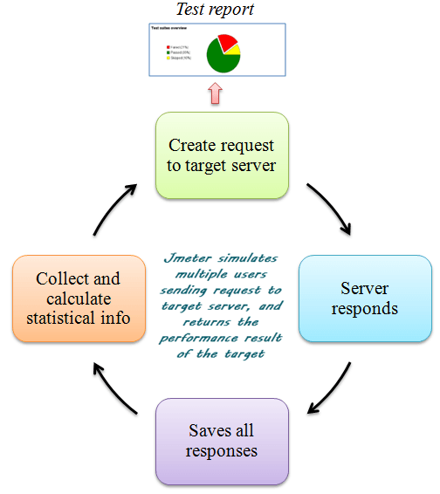

How To Establish Real Time Web Communication Environment In Jmeter Tool:
- Following Jmeter elements were configured as per Apache Standard Guidelines to establish real time web communication environment to correctly judge application’s performance
- Thread Group: Defines a pool of users that will ex execute a particular test case against your server. Basically each thread simulates one real user request to the server
- HTTP Cookie Manager: Stores and sends cookies just like a web browser.
- HTTP Cache Manager: Used to add caching functionality to HTTP requests within its scope to simulate browser cache feature.
- HTTP Request Defaults: Enables you set default values that your HTTP Request controllers use such as the application URL and port and is common from all requests

Is Jmeter Capable To Handle Multiple Data Sets:
- Multiple data set inputs such as: different username and password for each user logging in the application for a particular Jmeter test is handled with the help of CSV Data Set Config Element of Jmeter Tool
- CSV Data Set Config accepts the data from .csv files for Jmeter variables declared in test

How Is Dynamic Response Data Generated During Test Run Captured In Jmeter:
- Regular Expression Extractors are used to fetch values from HTTP response
- Values captured by regular expression extractors can be used as variable in further request samples of the Jmeter test
- Generated Cookie values can also be fetched as variables in J-Meter and used if required

How Is Correctness Of Web Requests Captured In Jmeter Established:
- In the initial phases of Jmeter POC development for five most basic/critical functionalities of the application; the web requests captured by Jmeter were compared with the web request received when application is actually navigated via UI to perform those functionalities
- HTTP request for UI navigation were viewed in console of IE browser using Developer Tools

How Is Correctness Of Performance Results Provided By Jmeter Established:
- A single test was run thrice for different user sets (1,5,10,20, 50 and 100 users) and then it was evaluated on the evaluated criteria:
  - For a particular user set in all three runs (for instance: three runs with 5 users of a particular test) performance results should be consistent
  - Difference between different performance parameters (such as Average Time, Min Time, Max Time, Throughput) should not be much when running tests with two different user sets which are close to each other (for instance: runs with 5 users and 10 users of a particular test)
  - Finally, performance results already available for different test scenarios from other performance test tools such as load runner and QA load were compared with those provided by Jmeter to ensure consistency and correctness

How Is User Friendly Performance Test Report Generated For Jmeter:
- ANT build tool is used to generate performance test results in HTML format. In- built Jmeter dashboard report generator is not used as:
  - It provides time values in milliseconds and not in seconds hence if the time span is higher say 20 seconds or so it becomes difficult to comprehend the actual value; by looking at the large millisecond value
  - No information about the total user count failed or passed at each and every breakpoint is provided
  - Dashboard Report generator has been recently added to Jmeter in version 3.0. It is not stable and contains bugs which are being fixed by Apache

How Is Memory Low Issue Taken Care While Running Test For Large User Count:
- To avoid low memory issues:
  - Test Engineer should run Jmeter test cases from command prompt only
  - Test Engineer should increase the memory allocated to Jmeter as a process by modifying Jmeter properties in Jmeter batch file

Is It Possible To Run Jmeter Test Cases As batch Or Suite:
- Unlike Load Runner it is possible to run Jmeter performance test cases in a batch or suite thus greatly saving time and effort of performance test engineer.
- This can be achieved by using Ant and creating separate batch files for each test and then calling them using a master batch file
- In the test batch file only user can specify the variouss parameters such as user count, ramp-up period, run count as ANT properties

Revision History Of The Work Product:
# | Date | Version # | Section Changed | Details of changes made | Approved By
1 | 14th Nov 2016 | 0.00 D |  | 1. Created

